TECHNOLOGY CORNER
5. From Z-Scores to Area, and Vice Versa

Finding areas: The NORMALD_CDF() command on the HP Prime can be used to find lower-tail areas under a Normal curve. The syntax is NORMALD_CDF(mean, standard deviation, value) and it returns the area to the left of value under a Normal cumulative density function with the given mean and standard deviation.

- What proportion of observations from the standard Normal distribution are greater than –1.78? Recall that the standard Normal distribution has mean 0 and standard deviation 1. Since this calculation involves the area to the right of z=-1.78, we use 1-NORMAL_CDF(0,1,-1.78).
  - Press H to go to the Home view
  - Type 1-, then press D, tap Probability, tap Cumulative, and tap Normal to select the Normal cumulative density function NORMALD_CDF(μ,σ,x)
  - Press N o x o A s; then press E to complete the formula
The mean and standard deviation are optional for the standard Normal curve, so 1-NORMAL_CDF(-1.78) returns the same result.
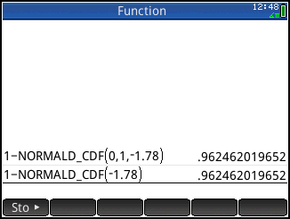
- What proportion of observations from the standard Normal distribution is between –1.25 and 0.81? In this case, we subtract two areas to find the area between the two values.
The screen shot below confirms our earlier result of 0.6854 using Table A.
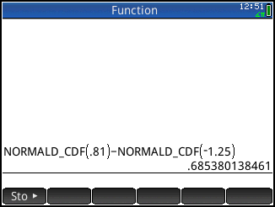
Working backward: The HP Prime NORMALD_ICDF() function calculates the z-value corresponding to a given percentile in a Normal distribution. For this command, the syntax is NORMAL_ICDF (mean, standard deviation, area to the left).

- What is the 90th percentile of the standard Normal distribution?
  - Press D, tap Probability, tap Inverse, and tap Normal to select the Normal inverse cumulative density function NORMALD_ICDF(μ, σ, x)
  - Complete the formula NORMALD_ICDF(0, 1, 0.9) and press E .
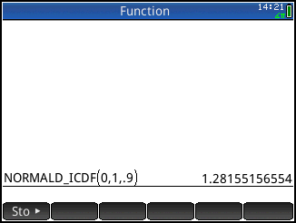
  - For the standard Normal distribution, you can omit the mean and standard deviation and just enter NORMALD_ICDF(0.9) as shown below.
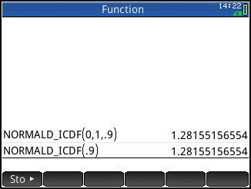
The results match what we got using Table A.

