TECHNOLOGY CORNER
4. Computing Numerical Summaries with HP Prime

Let’s find numerical summaries for the travel times of North Carolina and New York workers from the previous Technology Corner (page 59). If you haven’t done so already, enter the North Carolina data in list D1 and the New York data in list D2 of the Statistics 1Var app.

- Find the summary statistics for the North Carolina and New York travel times. You can view the five-number summaries for both data sets in a single table.
  - Press M to enter the Numeric view
  - Enter the data from the North Carolina and New York travel times in D1 and D2, respectively (if you haven’t already). The data can be found on Page 52.
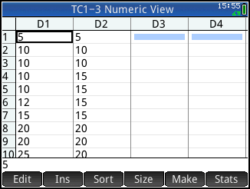
- Tap to view the summary statistics page for both data sets
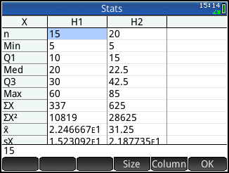
  - The five-number summaries appear near the top of the list. H1 has summary statistics for the North Carolina data and H2 has the New York summary. Tap and drag to scroll the rest of the list or tap and choose a smaller font to see the entirety of both summaries.
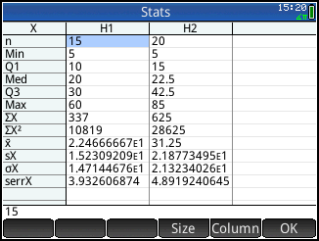
  - Tap to return to the Numeric view when you are done.

