TECHNOLOGY CORNER
7. Scatterplots on the HP Prime

Making scatterplots with technology is much easier than constructing them by hand. We’ll use the SEC football data from page 146 to show how to construct a scatterplot on an HP Prime.

- Press I and tap on the Statistics 2Var app icon. Enter the data values into the lists C1 and C2. Put the points per game in C1 and the number of wins in C2.
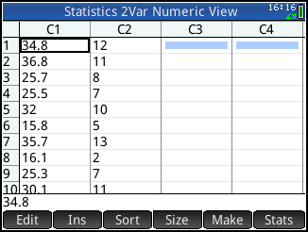
- Define the scatterplot in the Symbolic view of the app (Press Y ). Specify the settings shown below; the defaults for H1 already correspond to using C1 and C2 with a linear fit, so no changes may be needed.
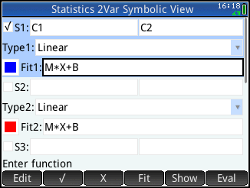
- Press V and select Autoscale. The calculator will set the window dimensions automatically by looking at the values in the lists C1 and C2 in the Numeric view.
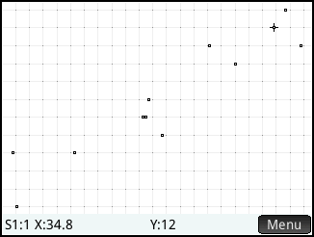

The tracer shows that you are tracing S1 and are on the first data point (S1:1), with an x-value of 34.8 and a y-value of 12.

Tap on a data point to move the tracer to that point or use > and < to move the tracer.

Note: if the Plot view shows the linear fit as well, just tap and to hide the fit.

Notice that there are no scales on the axes and that the axes are not labeled. If you copy a scatterplot from your calculator onto your paper, make sure that you scale and label the axes.

