TECHNOLOGY CORNER
19. Computing P-values from t distributions on the HP Prime

You can use the STUDENT_CDF command on the HP Prime to calculate areas under a t distribution curve. The syntax of the command is STUDENT_CDF(degrees of freedom, value) and it calculates the area to the left of the desired critical value of a t distribution with the given degrees of freedom. Let’s use the cumulative t command to find the P-values from the last two examples.

- Better batteries: Find P(t ≥ 1.54). Since this problem involves the area to the right, we will use 1-STUDENT_CDF(14, 1.54)
  - Press H to go to the Home view
  - Enter x w
  - Press D , tap Probability, then tap Cumulative and select T
  - Complete the command 1-STUDENT_CDF(14, 1.54) and press E.
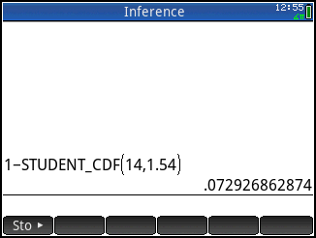
- Two-sided test: Find P(t ≤ -3.17 or t ≥ 3.17). Since this is a two-sided test, we will double the lower-tail probability.
  - Enter the command 2*STUDENT_CDF(36, -3.17)
