TECHNOLOGY CORNER
16. Inverse t on the HP Prime

HP Prime allows you to find critical values t* using the inverse t command. As with the inverse Normal command, you have to enter the area to the left of the desired critical value. The inverse t command on the HP Prime is STUDENT_ICDF() and the syntax is STUDENT_ICDF(degrees of freedom, area to the left). Let’s use the inverse t command to find the critical values in parts (a) and (b) of the example.

  - Press H to go to the Home view
  - Press D , tap Probability, then tap Inverse and select T
  - Complete the command STUDENT_ICDF(11,0.025) and press E.
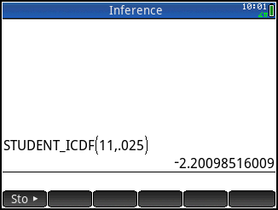
  - Repeat to enter the command STUDENT_ICDF(47, 0.05)
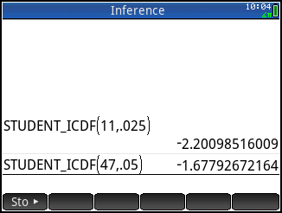
Note that the t critical values are t* = 2.201 and
t* = 1.678, respectively.

