

**TECHNOLOGY CORNER**

15. Confidence interval for a population proportion on the HP Prime

HP Prime can be used to construct a confidence interval for an unknown population proportion. We’ll demonstrate using the previous example. Of *n* = 439 teens surveyed, *X* = 246 said they thought that young people should wait to have sex until after marriage. To construct a 95% confidence interval:

* + Press I and tap the *Inference* app icon.
  + Select the **Method** field, tap  and select *Confidence Interval*
  + In the **Type** field, select *Z-Int: 1 π*

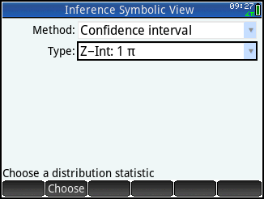

* + Press M to enter the Numeric view. Enter x=246, n=349, and C=0.95.

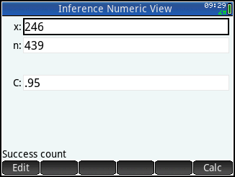

* + Tap  to see the results numerically.

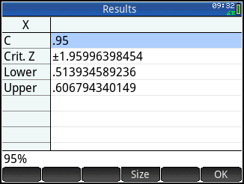

* + Tap  to return to the Numeric view

You can also view the confidence interval graphically.

* + Press P to see the Plot view. The confidence interval is shown at the bottom, with the  value and the critical z-values.

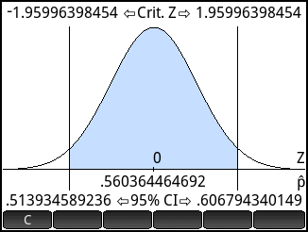

* Tap  to activate the dynamic confidence interval. Press = and \ to increase and decrease the confidence level and see the effect on the size of the confidence interval.

