TECHNOLOGY CORNER
10. Choosing an SRS on the HP Prime

Let’s use the HP Prime graphing calculator to select an SRS of 10 students from the Canyon del Oro High School roster.

- Generate a random number between 1 and 1750 and heck that your calculator’s random number generator is seeded differently than your classmates.
  - From the Home view, press D, tap Probability, tap Random, and select Integer. Complete the command RandInt(1, 1750) and press E.
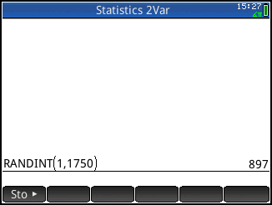
Compare your results with those of your classmates. If several students got the same number, you’ll need to seed your calculator’s random integer generator with different numbers before you proceed.

- Press D, tap Probability, tap Random, and select Seed. Complete the command RANDSEED(number) and press E. Use your phone number, street address, or other multi-digit number as the argument.
- Now repeat the RANDINT(1, 1750) command (just tap it twice to copy it and press E). Continue to press E until you have ten different numbers.

- Randomly generate 10 distinct numbers from 1 to 1750. The randperm(n) command will give a random permutation of the first n counting numbers. The command randperm(1750) will generate a random permutation of the integers from 1 to 1750. The first ten numbers listed give the labels of the chosen students.
  - Press D , tap , press q to jump to the entries that start with the letter R, and scroll to randperm.
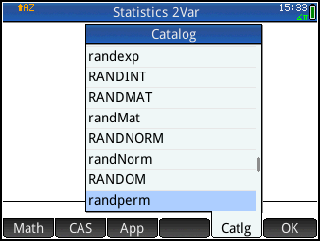
  - Complete the randperm(1750) command and press E.
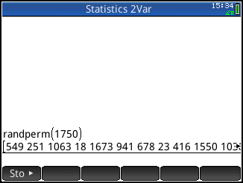
The first 10 numbers listed give the labels of the chosen students.

