TECHNOLOGY CORNER
9. Residual plots on the HP Prime

Let’s continue the analysis of the Ford F-150 miles driven and price data from the previous Technology Corner (page 171). You should have already made a scatterplot, calculated the equation of the least-squares regression line, and graphed the line on your plot. Now, we want to calculate residuals and make a residual plot. We can use the Statistic 2Var app function Resid to calculate the residuals and store them in a list. The syntax for the Resid function is Resid(Sn), where Sn is one of the five Symbolic view definitions S1-S5.

- Calculate the residuals and store them in list C3 of the Statistics 2Var app.
  - With H1 defined from the previous Technology Corner, press H to go to the Home view. Press D, tap , tap Statistics 2Var, and select Resid. Enter S1 as the argument and tap after the right parenthesis. Tap then enter C3 and press E.
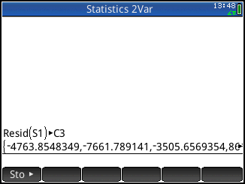
- Tap M to see the residuals in list C3 of the Numeric view.
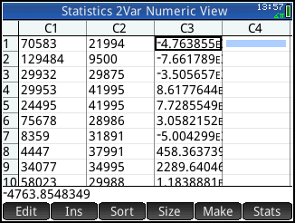
- Uncheck H1 (select it and tap ). Specify H2 with list C1 as the x-variable and list C3 as the y-variable.

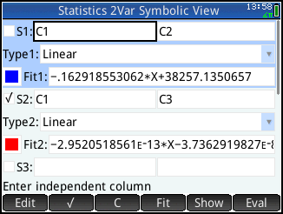
- Press P to see the residual plot.
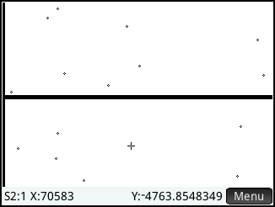
The x axis in the residual plot serves as a reference line: points above this line correspond to positive residuals and points below the line correspond to negative residuals.

- Press M to return to the Numeric view and tap . Tap to see the sum of the residuals, which is very near zero. The standard deviation of the residuals is shown as well.

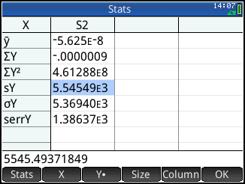

Tap when you are done.

