TECHNOLOGY CORNER
11. Analyzing Random Variables on the HP Prime

Let’s explore what HP Prime can do using the random variable X = Apgar score of a randomly selected newborn.

- Start in the Numeric view of the Statistics 1Var app by entering the values of the random variable in list D1. Enter the corresponding frequencies in list D2 (multiply the probabilities by 1000). The data can be found on Page 353.
  - Press I and tap the Statistics 1Var app icon
  - Type the values into list D1 and the frequencies in D2
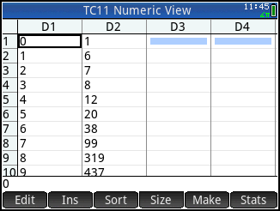
- To graph a histogram of the distribution, set up H1 in the Symbolic view of the app.
  - Press Y to open the Symbolic view; press S J to return the view to its default settings. Change the H1 Freq field to use D2 as the frequencies and choose Histogram for Plot 1.
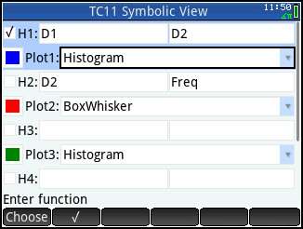
- Plot the histogram in the Plot view.
  - Press V and tap Autoscale
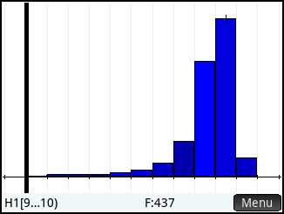
- Calculate the mean and standard deviation of the random variable
  - Press M to enter the Numeric view
  - Tap to view summary statistics for the distribution.
  - Tap and drag to scroll to the bottom of the list (or use \) to see the mean and standard deviation
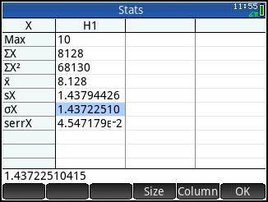
  - Tap to return to the Numeric view

