TECHNOLOGY CORNER
8. Least-squares regression lines on the HP Prime

Let’s use the Ford F-150 data to show how to find the equation of the least-squares regression line on the HP Prime. Here are the data again:

Miles driven | 70,583 | 129,484 | 29,932 | 29,953 | 24,495 | 75,678 | 8,359 | 4,447
Price (in dollars) | 21,994 | 9,500 | 29,875 | 41,995 | 41,995 | 28,986 | 31,891 | 37,991
Miles driven | 34,077 | 58,023 | 44,447 | 68,474 | 144,162 | 140,776 | 29,397 | 131,385
Price (in dollars) | 34,995 | 29,988 | 22,896 | 33,961 | 16,883 | 20,897 | 27,495 | 13,997

- Press I and tap on the Statistics 2Var app icon. Enter the data values into the lists C1 and C2. Put the miles driven data in C1 and the price data in C2. Then make a scatterplot. Refer to the Technology Corner on page 150.
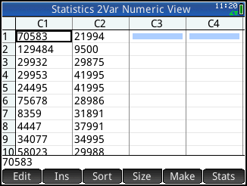
- Define the scatterplot and regression line in the Symbolic view of the app (Press Y). Specify the settings shown below; the defaults for H1 already correspond to using C1 and C2 with a linear fit, so no changes may be needed. Tap to activate plotting the linear fit as well as the scatterplot. The small white dot after the label indicates that fit plotting is active in the Plot view. You can tap it again to de-activate fit plotting at any time. This toggle appears in the Plot view as well.
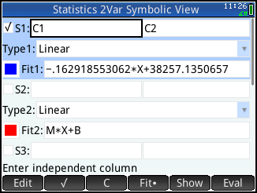
- Press V and select Autoscale to see both the scatterplot and the linear fit. Tap to move the tracer (or use > and < ). Use \ and = to move between tracing the scatterplot and tracing the fit.
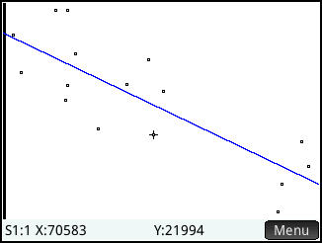
- To find the predicted price of an F-150 truck with 100,000 miles, tap and . Enter 100,000 and tap . Tap to show the tracer coordinates, indicating that an F-150 truck with 100,000 miles driven would have a price of approximately $21,965.
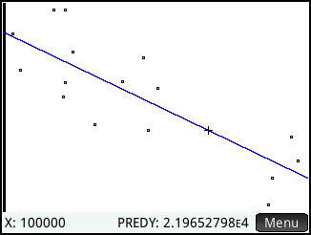

- Press M to enter the Numeric view and tap to see summary statistics related to the two data sets. The linear correlation coefficient (r) and R² values are shown.
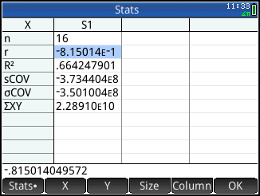
Tap to return to the Numeric view when you are done.
- Press Y to enter the Symbolic view. The linear regression equation is shown in Fit1.
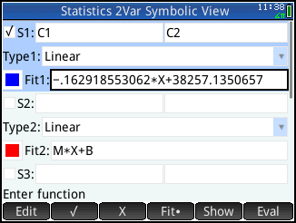
- You can use the linear fit to make predictions from the Home view using the PredX and PredY commands. To repeat the previous calculation of the price of an F-150 with 100,000 miles, go to the Home view. Press D , tap , tap Statistic 2Var, and select PredY.

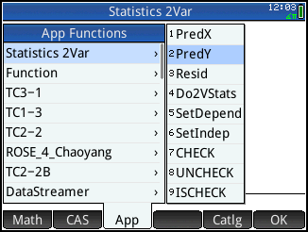

- Complete the command PREDY(100,000) and press E .
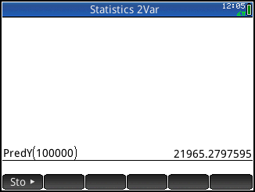
- Save these lists for later use. In the Home view, enter C1▸MILES and C2▸PRICE. You will be prompted to confirm that you want to create these new variables. Simply tap to proceed.
