TECHNOLOGY CORNER
6. Normal probability plots

To make a Normal probability plot for a set of quantitative data:

- Enter the data values in list D1 of the Statistics 1Var app. We’ll use the state unemployment rates data from page 122.
- Define H1 as shown in the Symbolic view of the app. (Tap and select Normal Probability for Plot1.)
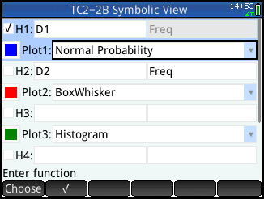
- Press V and select Autoscale to see the finished graph.
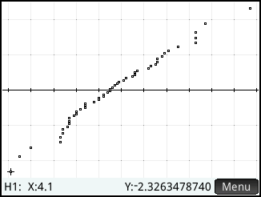
Interpretation: The Normal probability plot is quite linear, so it is reasonable to believe that the data follow a Normal distribution.

