TECHNOLOGY CORNER
2. Histograms on the HP Prime

- Enter the data for the percent of state residents born outside the United States in the Numeric view of the Statistics 1Var app. The data can be found on Page 33.
  - Press I and tap the Statistics 1Var app icon
  - Type the values into list D1
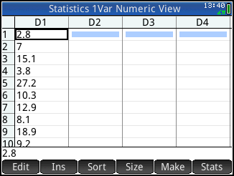
- Set up a histogram in the Symbolic view of the app
  - Press Y to open the Symbolic view; press S J to return the view to its default settings. By default, H1 is already set to create a histogram based on the data in list D1.
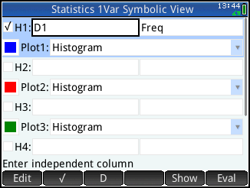
- Plot the histogram in the Plot view of the app.
  - Press V and tap Autoscale
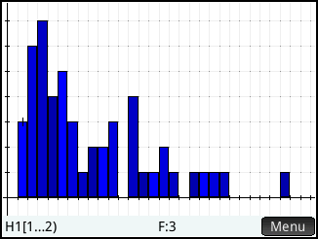
- Change the size of each class using H
Width in the Plot Setup.
  - Press S P to enter the Plot Setup.
  - Change H Width to 5 and X Tick to 5
  - Change the X Rng and Y Rng values as shown in the figure below
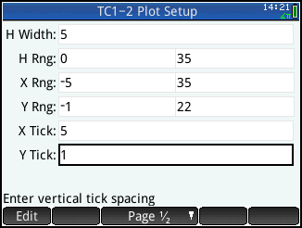
  - Press P to return to the histogram
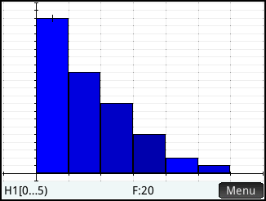
  - Tap anywhere on the display to move the tracer (or use > and <)

- To match Figure 1.17, just change H Width to 2.5.

