TECHNOLOGY CORNER
3. Making Box Plots on the HP Prime

The HP Prime can display up to 5 boxplots (box and whisker plots) in the same viewing window. Let’s use the calculator to make side-by-side boxplots of the travel time to work data for the samples from North Carolina and New York.

- Enter the travel time data for North Carolina in list D1 and for New York in list D2 of the Statistics 1Var app. The data can be found on Page 52.
  - Press I and tap on the Statistics 1Var app icon
  - Type the values into lists D1 and D2
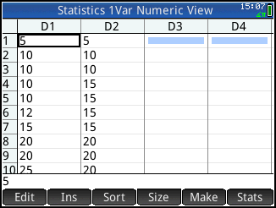
- Set up the two boxplots in the Symbolic view of the app
  - Press Y to open the Symbolic view
  - Set H1 to use D1 for the data and set Plot1 to be BoxWhisker (tap to make a selection)
  - Set H2 to use D2 for data and set Plot2 to be BoxWhisker
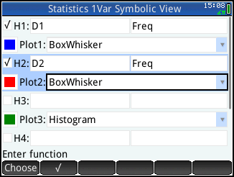
- Use the Autoscale option to display the side-by-side boxplots. Then tap or trace to view the five-number summary.
  - Press V and tap on Autoscale
  - Tap anywhere on the display to move the tracer and view the 5-number summary (or use > and <)
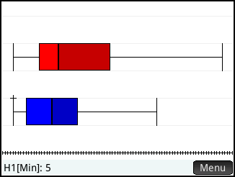
- You can also view the five-number summaries for both data sets in a table
  - Press M to enter the Numeric view and tap .
