TECHNOLOGY CORNER
13. Binomial Probability on the HP Prime

There are two handy commands on HP Prime for finding binomial probabilities: BINOMIAL() and BINOMIAL_CDF(). The inputs for both commands are the number of trials n, the values of interest for the binomial random variable X, and the success probability p.
BINOMIAL(n, k, p) computes P(X = k)
BINOMIAL_CDF(n, p, k) computes P(X ≤ k)
Let’s use these commands to confirm our answers in the previous example. Remember that the probability that a child from a particular set of parents has type O blood is 0.25.

- Find the probability that exactly 3 of the 5 children from a particular set of parents have type O blood.

  - Press H to enter the Home view. Press D and tap to open the Math menu.
  - Tap Probability, then Density, and select Binomial.

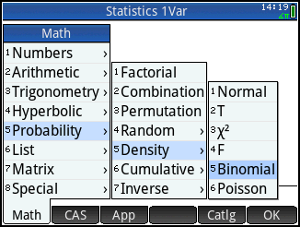

  - Complete the command BINOMIAL(5, 3, 0.25) and press E.
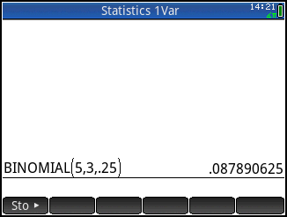
These results agree with our previous answer using the binomial probability formula: 0.08789.
- Should the parents be surprised if more than 3 of their children have type O blood?

To find P(X > 3), use the complement rule:
P(X > 3) = 1 – P(X ≤ 3)
P(X > 3) = 1 – BINOMIAL_CDF(5, 3, 0.25)

  - Enter x w
  - Press D and tap to open the Math menu.
  - Tap Probability, then Cumulative, and select Binomial.
  - Complete the command 1 – BINOMIAL_CDF(5, 0.25, 3) and press E.
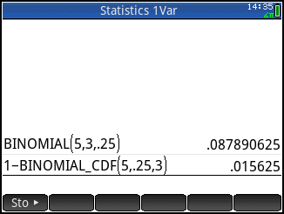
This result agrees with our previous answer using the binomial probability formula: 0.01563.

