

**TECHNOLOGY CORNER**

18. One-proportion z test on the HP Prime

HP Prime can be used to test a claim about a population proportion. We’ll demonstrate using the previous example. In a random sample of size *n* = 500, the supervisor found *X* = 47 potatoes with blemishes. To perform a significance test:

* + Press I and tap the *Inference* app icon.
  + Select the **Method** field, tap  and select *Hypothesis Test*
  + In the **Type** field, select *Z-Test: 1 π*
  + For the alternative hypothesis, select *π>π0*

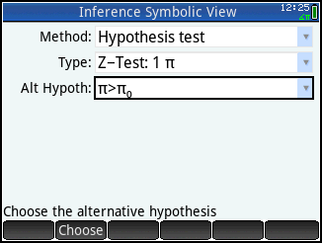

* + Press M to enter the Numeric view. Enter x=47, n=500, π0=0.08, and α=0.05.

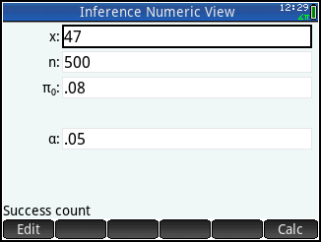

* + Tap  to see the results numerically.

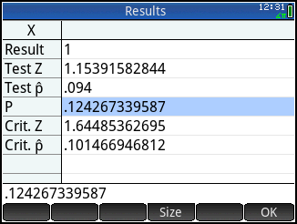

* + Tap  to return to the Numeric view

You can also view the confidence interval graphically.

* + Press P to see the Plot view. The test probability is shown at the top, with the test z and  values.

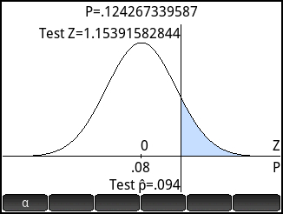

* Tap  for an alternate view of the test results. Here, the area associated with the alternative hypothesis and α-level is shown shaded in blue. The test z and  values are shown as well. The test values are clearly not in the shaded reject region. Press = and \ to increase and decrease the α-level.

